Ukulele Songbook

Original Songs!

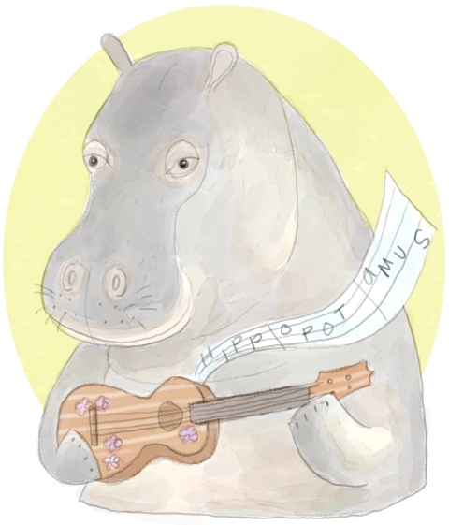

*(c) 2013 Rosangela Canino-Koning*

|  |
| --- |
|  |
|  |
|  |
|  |

|  |
| --- |
|  |
|  |
|  |
|  |

|  |
| --- |
|  |
|  |
|  |
|  |

|  |
| --- |
|  |
|  |
|  |
|  |

|  |
| --- |
|  |
|  |
|  |
|  |

|  |
| --- |
|  |
|  |
|  |
|  |

|  |
| --- |
|  |
|  |
|  |
|  |

|  |
| --- |
|  |
|  |
|  |
|  |

|  |
| --- |
|  |
|  |
|  |
|  |

|  |
| --- |
|  |
|  |
|  |
|  |

|  |
| --- |
|  |
|  |
|  |
|  |

|  |
| --- |
|  |
|  |
|  |
|  |

|  |
| --- |
|  |
|  |
|  |
|  |

|  |
| --- |
|  |
|  |
|  |
|  |

|  |
| --- |
|  |
|  |
|  |
|  |

|  |
| --- |
|  |
|  |
|  |
|  |

|  |
| --- |
|  |
|  |
|  |
|  |

|  |
| --- |
|  |
|  |
|  |
|  |

|  |
| --- |
|  |
|  |
|  |
|  |

|  |
| --- |
|  |
|  |
|  |
|  |

|  |
| --- |
|  |
|  |
|  |
|  |

|  |
| --- |
|  |
|  |
|  |
|  |

|  |
| --- |
|  |
|  |
|  |
|  |

|  |
| --- |
|  |
|  |
|  |
|  |

|  |
| --- |
|  |
|  |
|  |
|  |

|  |
| --- |
|  |
|  |
|  |
|  |

|  |
| --- |
|  |
|  |
|  |
|  |

|  |
| --- |
|  |
|  |
|  |
|  |

|  |
| --- |
|  |
|  |
|  |
|  |

|  |
| --- |
|  |
|  |
|  |
|  |

|  |
| --- |
|  |
|  |
|  |
|  |

|  |
| --- |
|  |
|  |
|  |
|  |

|  |
| --- |
|  |
|  |
|  |
|  |

|  |
| --- |
|  |
|  |
|  |
|  |

|  |
| --- |
|  |
|  |
|  |
|  |

|  |
| --- |
|  |
|  |
|  |
|  |

|  |
| --- |
|  |
|  |
|  |
|  |

|  |
| --- |
|  |
|  |
|  |
|  |

|  |
| --- |
|  |
|  |
|  |
|  |

|  |
| --- |
|  |
|  |
|  |
|  |

|  |
| --- |
|  |
|  |
|  |
|  |

|  |
| --- |
|  |
|  |
|  |
|  |

|  |
| --- |
|  |
|  |
|  |
|  |

|  |
| --- |
|  |
|  |
|  |
|  |

|  |
| --- |
|  |
|  |
|  |
|  |

|  |
| --- |
|  |
|  |
|  |
|  |

|  |
| --- |
|  |
|  |
|  |
|  |

|  |
| --- |
|  |
|  |
|  |
|  |

|  |
| --- |
|  |
|  |
|  |
|  |

|  |
| --- |
|  |
|  |
|  |
|  |

|  |
| --- |
|  |
|  |
|  |
|  |

|  |
| --- |
|  |
|  |
|  |
|  |

|  |
| --- |
|  |
|  |
|  |
|  |

|  |
| --- |
|  |
|  |
|  |
|  |

|  |
| --- |
|  |
|  |
|  |
|  |

|  |
| --- |
|  |
|  |
|  |
|  |

|  |
| --- |
|  |
|  |
|  |
|  |

|  |
| --- |
|  |
|  |
|  |
|  |

|  |
| --- |
|  |
|  |
|  |
|  |

|  |
| --- |
|  |
|  |
|  |
|  |

|  |
| --- |
|  |
|  |
|  |
|  |

|  |
| --- |
|  |
|  |
|  |
|  |

|  |
| --- |
|  |
|  |
|  |
|  |

|  |
| --- |
|  |
|  |
|  |
|  |

|  |
| --- |
|  |
|  |
|  |
|  |

|  |
| --- |
|  |
|  |
|  |
|  |

|  |
| --- |
|  |
|  |
|  |
|  |

|  |
| --- |
|  |
|  |
|  |
|  |

|  |
| --- |
|  |
|  |
|  |
|  |

|  |
| --- |
|  |
|  |
|  |
|  |

|  |
| --- |
|  |
|  |
|  |
|  |

|  |
| --- |
|  |
|  |
|  |
|  |

|  |
| --- |
|  |
|  |
|  |
|  |

|  |
| --- |
|  |
|  |
|  |
|  |

|  |
| --- |
|  |
|  |
|  |
|  |

|  |
| --- |
|  |
|  |
|  |
|  |

|  |
| --- |
|  |
|  |
|  |
|  |

|  |
| --- |
|  |
|  |
|  |
|  |

|  |
| --- |
|  |
|  |
|  |
|  |

|  |
| --- |
|  |
|  |
|  |
|  |

|  |
| --- |
|  |
|  |
|  |
|  |

|  |
| --- |
|  |
|  |
|  |
|  |

|  |
| --- |
|  |
|  |
|  |
|  |

|  |
| --- |
|  |
|  |
|  |
|  |

|  |
| --- |
|  |
|  |
|  |
|  |

|  |
| --- |
|  |
|  |
|  |
|  |

|  |
| --- |
|  |
|  |
|  |
|  |

|  |
| --- |
|  |
|  |
|  |
|  |

|  |
| --- |
|  |
|  |
|  |
|  |

|  |
| --- |
|  |
|  |
|  |
|  |

|  |
| --- |
|  |
|  |
|  |
|  |

|  |
| --- |
|  |
|  |
|  |
|  |

|  |
| --- |
|  |
|  |
|  |
|  |

|  |
| --- |
|  |
|  |
|  |
|  |

|  |
| --- |
|  |
|  |
|  |
|  |

|  |
| --- |
|  |
|  |
|  |
|  |

|  |
| --- |
|  |
|  |
|  |
|  |

|  |
| --- |
|  |
|  |
|  |
|  |

|  |
| --- |
|  |
|  |
|  |
|  |

|  |
| --- |
|  |
|  |
|  |
|  |

|  |
| --- |
|  |
|  |
|  |
|  |

|  |
| --- |
|  |
|  |
|  |
|  |

|  |
| --- |
|  |
|  |
|  |
|  |

|  |
| --- |
|  |
|  |
|  |
|  |

|  |
| --- |
|  |
|  |
|  |
|  |

|  |
| --- |
|  |
|  |
|  |
|  |

|  |
| --- |
|  |
|  |
|  |
|  |

|  |
| --- |
|  |
|  |
|  |
|  |

|  |
| --- |
|  |
|  |
|  |
|  |

|  |
| --- |
|  |
|  |
|  |
|  |

|  |
| --- |
|  |
|  |
|  |
|  |

|  |
| --- |
|  |
|  |
|  |
|  |

|  |
| --- |
|  |
|  |
|  |
|  |

|  |
| --- |
|  |
|  |
|  |
|  |

|  |
| --- |
|  |
|  |
|  |
|  |

|  |
| --- |
|  |
|  |
|  |
|  |

|  |
| --- |
|  |
|  |
|  |
|  |

|  |
| --- |
|  |
|  |
|  |
|  |

|  |
| --- |
|  |
|  |
|  |
|  |

|  |
| --- |
|  |
|  |
|  |
|  |

|  |
| --- |
|  |
|  |
|  |
|  |

|  |
| --- |
|  |
|  |
|  |
|  |

|  |
| --- |
|  |
|  |
|  |
|  |

|  |
| --- |
|  |
|  |
|  |
|  |

|  |
| --- |
|  |
|  |
|  |
|  |

|  |
| --- |
|  |
|  |
|  |
|  |

|  |
| --- |
|  |
|  |
|  |
|  |

|  |
| --- |
|  |
|  |
|  |
|  |

|  |
| --- |
|  |
|  |
|  |
|  |

|  |
| --- |
|  |
|  |
|  |
|  |

|  |
| --- |
|  |
|  |
|  |
|  |

|  |
| --- |
|  |
|  |
|  |
|  |

|  |
| --- |
|  |
|  |
|  |
|  |

|  |
| --- |
|  |
|  |
|  |
|  |

|  |
| --- |
|  |
|  |
|  |
|  |

|  |
| --- |
|  |
|  |
|  |
|  |

|  |
| --- |
|  |
|  |
|  |
|  |

|  |
| --- |
|  |
|  |
|  |
|  |

|  |
| --- |
|  |
|  |
|  |
|  |

|  |
| --- |
|  |
|  |
|  |
|  |

|  |
| --- |
|  |
|  |
|  |
|  |

|  |
| --- |
|  |
|  |
|  |
|  |

|  |
| --- |
|  |
|  |
|  |
|  |

|  |
| --- |
|  |
|  |
|  |
|  |

|  |
| --- |
|  |
|  |
|  |
|  |

|  |
| --- |
|  |
|  |
|  |
|  |

|  |
| --- |
|  |
|  |
|  |
|  |

|  |
| --- |
|  |
|  |
|  |
|  |

|  |
| --- |
|  |
|  |
|  |
|  |

|  |
| --- |
|  |
|  |
|  |
|  |

|  |
| --- |
|  |
|  |
|  |
|  |

|  |
| --- |
|  |
|  |
|  |
|  |

|  |
| --- |
|  |
|  |
|  |
|  |

|  |
| --- |
|  |
|  |
|  |
|  |

|  |
| --- |
|  |
|  |
|  |
|  |

|  |
| --- |
|  |
|  |
|  |
|  |

|  |
| --- |
|  |
|  |
|  |
|  |

|  |
| --- |
|  |
|  |
|  |
|  |

|  |
| --- |
|  |
|  |
|  |
|  |

|  |
| --- |
|  |
|  |
|  |
|  |

|  |
| --- |
|  |
|  |
|  |
|  |

|  |
| --- |
|  |
|  |
|  |
|  |

|  |
| --- |
|  |
|  |
|  |
|  |

|  |
| --- |
|  |
|  |
|  |
|  |

|  |
| --- |
|  |
|  |
|  |
|  |

|  |
| --- |
|  |
|  |
|  |
|  |

|  |
| --- |
|  |
|  |
|  |
|  |

|  |
| --- |
|  |
|  |
|  |
|  |

|  |
| --- |
|  |
|  |
|  |
|  |

|  |
| --- |
|  |
|  |
|  |
|  |

|  |
| --- |
|  |
|  |
|  |
|  |

|  |
| --- |
|  |
|  |
|  |
|  |

|  |
| --- |
|  |
|  |
|  |
|  |

|  |
| --- |
|  |
|  |
|  |
|  |

|  |
| --- |
|  |
|  |
|  |
|  |

|  |
| --- |
|  |
|  |
|  |
|  |

|  |
| --- |
|  |
|  |
|  |
|  |

|  |
| --- |
|  |
|  |
|  |
|  |

|  |
| --- |
|  |
|  |
|  |
|  |

|  |
| --- |
|  |
|  |
|  |
|  |

|  |
| --- |
|  |
|  |
|  |
|  |

|  |
| --- |
|  |
|  |
|  |
|  |

|  |
| --- |
|  |
|  |
|  |
|  |

|  |
| --- |
|  |
|  |
|  |
|  |

|  |
| --- |
|  |
|  |
|  |
|  |

|  |
| --- |
|  |
|  |
|  |
|  |

|  |
| --- |
|  |
|  |
|  |
|  |

|  |
| --- |
|  |
|  |
|  |
|  |

|  |
| --- |
|  |
|  |
|  |
|  |

|  |
| --- |
|  |
|  |
|  |
|  |

|  |
| --- |
|  |
|  |
|  |
|  |

|  |
| --- |
|  |
|  |
|  |
|  |

|  |
| --- |
|  |
|  |
|  |
|  |

|  |
| --- |
|  |
|  |
|  |
|  |

|  |
| --- |
|  |
|  |
|  |
|  |

|  |
| --- |
|  |
|  |
|  |
|  |

|  |
| --- |
|  |
|  |
|  |
|  |

|  |
| --- |
|  |
|  |
|  |
|  |

|  |
| --- |
|  |
|  |
|  |
|  |

|  |
| --- |
|  |
|  |
|  |
|  |

|  |
| --- |
|  |
|  |
|  |
|  |

|  |
| --- |
|  |
|  |
|  |
|  |

|  |
| --- |
|  |
|  |
|  |
|  |

|  |
| --- |
|  |
|  |
|  |
|  |

|  |
| --- |
|  |
|  |
|  |
|  |

|  |
| --- |
|  |
|  |
|  |
|  |

|  |
| --- |
|  |
|  |
|  |
|  |

|  |
| --- |
|  |
|  |
|  |
|  |

|  |
| --- |
|  |
|  |
|  |
|  |

|  |
| --- |
|  |
|  |
|  |
|  |

|  |
| --- |
|  |
|  |
|  |
|  |

|  |
| --- |
|  |
|  |
|  |
|  |

|  |
| --- |
|  |
|  |
|  |
|  |

|  |
| --- |
|  |
|  |
|  |
|  |

|  |
| --- |
|  |
|  |
|  |
|  |

|  |
| --- |
|  |
|  |
|  |
|  |

|  |
| --- |
|  |
|  |
|  |
|  |

|  |
| --- |
|  |
|  |
|  |
|  |

|  |
| --- |
|  |
|  |
|  |
|  |

|  |
| --- |
|  |
|  |
|  |
|  |

|  |
| --- |
|  |
|  |
|  |
|  |

|  |
| --- |
|  |
|  |
|  |
|  |

|  |
| --- |
|  |
|  |
|  |
|  |

|  |
| --- |
|  |
|  |
|  |
|  |

|  |
| --- |
|  |
|  |
|  |
|  |

|  |
| --- |
|  |
|  |
|  |
|  |

|  |
| --- |
|  |
|  |
|  |
|  |

|  |
| --- |
|  |
|  |
|  |
|  |

|  |
| --- |
|  |
|  |
|  |
|  |

|  |
| --- |
|  |
|  |
|  |
|  |

|  |
| --- |
|  |
|  |
|  |
|  |

|  |
| --- |
|  |
|  |
|  |
|  |

|  |
| --- |
|  |
|  |
|  |
|  |

|  |
| --- |
|  |
|  |
|  |
|  |

|  |
| --- |
|  |
|  |
|  |
|  |

|  |
| --- |
|  |
|  |
|  |
|  |

|  |
| --- |
|  |
|  |
|  |
|  |

|  |
| --- |
|  |
|  |
|  |
|  |

|  |
| --- |
|  |
|  |
|  |
|  |

|  |
| --- |
|  |
|  |
|  |
|  |

|  |
| --- |
|  |
|  |
|  |
|  |

|  |
| --- |
|  |
|  |
|  |
|  |

|  |
| --- |
|  |
|  |
|  |
|  |

|  |
| --- |
|  |
|  |
|  |
|  |

|  |
| --- |
|  |
|  |
|  |
|  |

|  |
| --- |
|  |
|  |
|  |
|  |

|  |
| --- |
|  |
|  |
|  |
|  |

|  |
| --- |
|  |
|  |
|  |
|  |

|  |
| --- |
|  |
|  |
|  |
|  |

|  |
| --- |
|  |
|  |
|  |
|  |

|  |
| --- |
|  |
|  |
|  |
|  |

|  |
| --- |
|  |
|  |
|  |
|  |

|  |
| --- |
|  |
|  |
|  |
|  |

|  |
| --- |
|  |
|  |
|  |
|  |

|  |
| --- |
|  |
|  |
|  |
|  |

|  |
| --- |
|  |
|  |
|  |
|  |

|  |
| --- |
|  |
|  |
|  |
|  |

|  |
| --- |
|  |
|  |
|  |
|  |

|  |
| --- |
|  |
|  |
|  |
|  |

|  |
| --- |
|  |
|  |
|  |
|  |

|  |
| --- |
|  |
|  |
|  |
|  |

|  |
| --- |
|  |
|  |
|  |
|  |

|  |
| --- |
|  |
|  |
|  |
|  |

|  |
| --- |
|  |
|  |
|  |
|  |

|  |
| --- |
|  |
|  |
|  |
|  |

|  |
| --- |
|  |
|  |
|  |
|  |

|  |
| --- |
|  |
|  |
|  |
|  |

|  |
| --- |
|  |
|  |
|  |
|  |

|  |
| --- |
|  |
|  |
|  |
|  |

|  |
| --- |
|  |
|  |
|  |
|  |

|  |
| --- |
|  |
|  |
|  |
|  |

|  |
| --- |
|  |
|  |
|  |
|  |

|  |
| --- |
|  |
|  |
|  |
|  |

|  |
| --- |
|  |
|  |
|  |
|  |

|  |
| --- |
|  |
|  |
|  |
|  |

|  |
| --- |
|  |
|  |
|  |
|  |

|  |
| --- |
|  |
|  |
|  |
|  |

|  |
| --- |
|  |
|  |
|  |
|  |

|  |
| --- |
|  |
|  |
|  |
|  |

|  |
| --- |
|  |
|  |
|  |
|  |

|  |
| --- |
|  |
|  |
|  |
|  |

|  |
| --- |
|  |
|  |
|  |
|  |

|  |
| --- |
|  |
|  |
|  |
|  |

|  |
| --- |
|  |
|  |
|  |
|  |

|  |
| --- |
|  |
|  |
|  |
|  |

|  |
| --- |
|  |
|  |
|  |
|  |

|  |
| --- |
|  |
|  |
|  |
|  |

|  |
| --- |
|  |
|  |
|  |
|  |

|  |
| --- |
|  |
|  |
|  |
|  |

|  |
| --- |
|  |
|  |
|  |
|  |

|  |
| --- |
|  |
|  |
|  |
|  |

|  |
| --- |
|  |
|  |
|  |
|  |

|  |
| --- |
|  |
|  |
|  |
|  |

|  |
| --- |
|  |
|  |
|  |
|  |

|  |
| --- |
|  |
|  |
|  |
|  |

|  |
| --- |
|  |
|  |
|  |
|  |

|  |
| --- |
|  |
|  |
|  |
|  |

|  |
| --- |
|  |
|  |
|  |
|  |

|  |
| --- |
|  |
|  |
|  |
|  |

|  |
| --- |
|  |
|  |
|  |
|  |

|  |
| --- |
|  |
|  |
|  |
|  |

|  |
| --- |
|  |
|  |
|  |
|  |

|  |
| --- |
|  |
|  |
|  |
|  |

|  |
| --- |
|  |
|  |
|  |
|  |

|  |
| --- |
|  |
|  |
|  |
|  |

|  |
| --- |
|  |
|  |
|  |
|  |

|  |
| --- |
|  |
|  |
|  |
|  |

|  |
| --- |
|  |
|  |
|  |
|  |

|  |
| --- |
|  |
|  |
|  |
|  |

|  |
| --- |
|  |
|  |
|  |
|  |

|  |
| --- |
|  |
|  |
|  |
|  |

|  |
| --- |
|  |
|  |
|  |
|  |

|  |
| --- |
|  |
|  |
|  |
|  |

|  |
| --- |
|  |
|  |
|  |
|  |

|  |
| --- |
|  |
|  |
|  |
|  |

|  |
| --- |
|  |
|  |
|  |
|  |

|  |
| --- |
|  |
|  |
|  |
|  |

|  |
| --- |
|  |
|  |
|  |
|  |

|  |
| --- |
|  |
|  |
|  |
|  |

|  |
| --- |
|  |
|  |
|  |
|  |

|  |
| --- |
|  |
|  |
|  |
|  |

|  |
| --- |
|  |
|  |
|  |
|  |

|  |
| --- |
|  |
|  |
|  |
|  |

|  |
| --- |
|  |
|  |
|  |
|  |

|  |
| --- |
|  |
|  |
|  |
|  |

|  |
| --- |
|  |
|  |
|  |
|  |

|  |
| --- |
|  |
|  |
|  |
|  |

|  |
| --- |
|  |
|  |
|  |
|  |

|  |
| --- |
|  |
|  |
|  |
|  |

|  |
| --- |
|  |
|  |
|  |
|  |

|  |
| --- |
|  |
|  |
|  |
|  |

|  |
| --- |
|  |
|  |
|  |
|  |

|  |
| --- |
|  |
|  |
|  |
|  |

|  |
| --- |
|  |
|  |
|  |
|  |

|  |
| --- |
|  |
|  |
|  |
|  |

|  |
| --- |
|  |
|  |
|  |
|  |

|  |
| --- |
|  |
|  |
|  |
|  |

|  |
| --- |
|  |
|  |
|  |
|  |

|  |
| --- |
|  |
|  |
|  |
|  |

|  |
| --- |
|  |
|  |
|  |
|  |

|  |
| --- |
|  |
|  |
|  |
|  |

|  |
| --- |
|  |
|  |
|  |
|  |

|  |
| --- |
|  |
|  |
|  |
|  |

|  |
| --- |
|  |
|  |
|  |
|  |

|  |
| --- |
|  |
|  |
|  |
|  |

|  |
| --- |
|  |
|  |
|  |
|  |

|  |
| --- |
|  |
|  |
|  |
|  |

|  |
| --- |
|  |
|  |
|  |
|  |

|  |
| --- |
|  |
|  |
|  |
|  |

|  |
| --- |
|  |
|  |
|  |
|  |

|  |
| --- |
|  |
|  |
|  |
|  |

|  |
| --- |
|  |
|  |
|  |
|  |

|  |
| --- |
|  |
|  |
|  |
|  |

|  |
| --- |
|  |
|  |
|  |
|  |

|  |
| --- |
|  |
|  |
|  |
|  |

|  |
| --- |
|  |
|  |
|  |
|  |

|  |
| --- |
|  |
|  |
|  |
|  |

|  |
| --- |
|  |
|  |
|  |
|  |

|  |
| --- |
|  |
|  |
|  |
|  |

|  |
| --- |
|  |
|  |
|  |
|  |

|  |
| --- |
|  |
|  |
|  |
|  |

|  |
| --- |
|  |
|  |
|  |
|  |

|  |
| --- |
|  |
|  |
|  |
|  |

|  |
| --- |
|  |
|  |
|  |
|  |

|  |
| --- |
|  |
|  |
|  |
|  |

|  |
| --- |
|  |
|  |
|  |
|  |

|  |
| --- |
|  |
|  |
|  |
|  |

|  |
| --- |
|  |
|  |
|  |
|  |

|  |
| --- |
|  |
|  |
|  |
|  |

|  |
| --- |
|  |
|  |
|  |
|  |

|  |
| --- |
|  |
|  |
|  |
|  |

|  |
| --- |
|  |
|  |
|  |
|  |

|  |
| --- |
|  |
|  |
|  |
|  |

|  |
| --- |
|  |
|  |
|  |
|  |

|  |
| --- |
|  |
|  |
|  |
|  |

|  |
| --- |
|  |
|  |
|  |
|  |

|  |
| --- |
|  |
|  |
|  |
|  |

|  |
| --- |
|  |
|  |
|  |
|  |

|  |
| --- |
|  |
|  |
|  |
|  |

|  |
| --- |
|  |
|  |
|  |
|  |

|  |
| --- |
|  |
|  |
|  |
|  |

|  |
| --- |
|  |
|  |
|  |
|  |

|  |
| --- |
|  |
|  |
|  |
|  |

|  |
| --- |
|  |
|  |
|  |
|  |

|  |
| --- |
|  |
|  |
|  |
|  |

|  |
| --- |
|  |
|  |
|  |
|  |

|  |
| --- |
|  |
|  |
|  |
|  |

|  |
| --- |
|  |
|  |
|  |
|  |

|  |
| --- |
|  |
|  |
|  |
|  |

|  |
| --- |
|  |
|  |
|  |
|  |

|  |
| --- |
|  |
|  |
|  |
|  |

|  |
| --- |
|  |
|  |
|  |
|  |

|  |
| --- |
|  |
|  |
|  |
|  |

|  |
| --- |
|  |
|  |
|  |
|  |

|  |
| --- |
|  |
|  |
|  |
|  |

|  |
| --- |
|  |
|  |
|  |
|  |

Chords – GCEA (Standard) Tuning

Maj/Minor

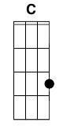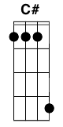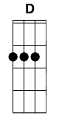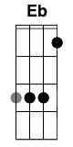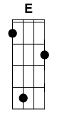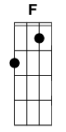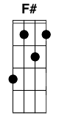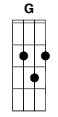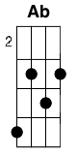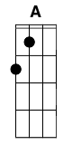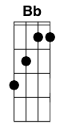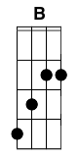

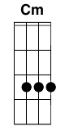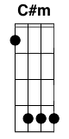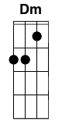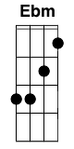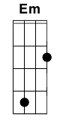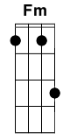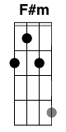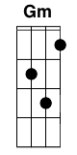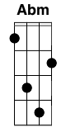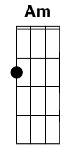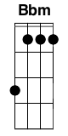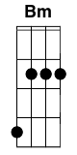

7

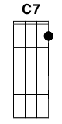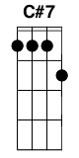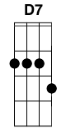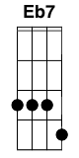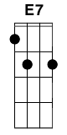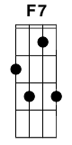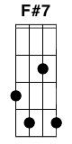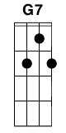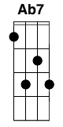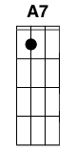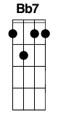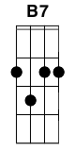

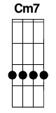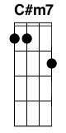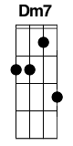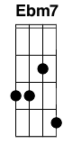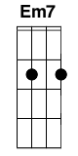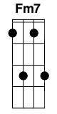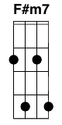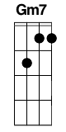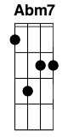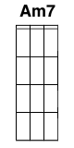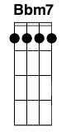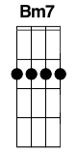

Maj

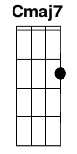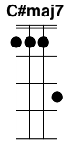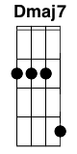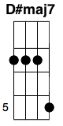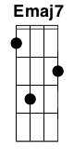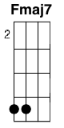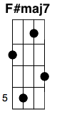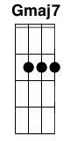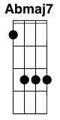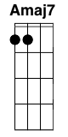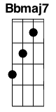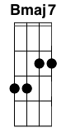

Sus

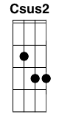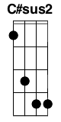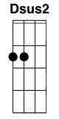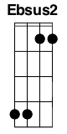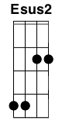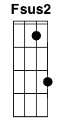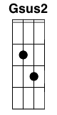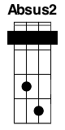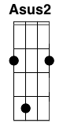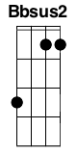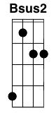

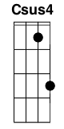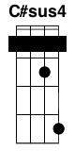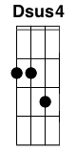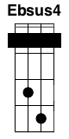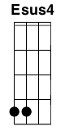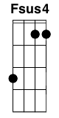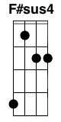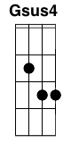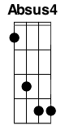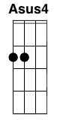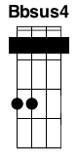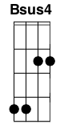

9

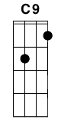 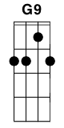 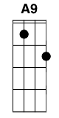

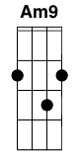

5

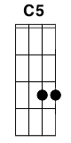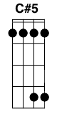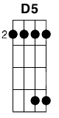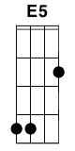 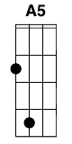 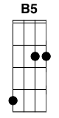

6

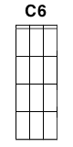 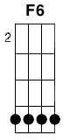 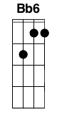

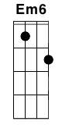 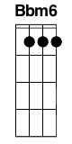

Misc

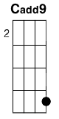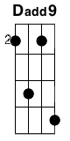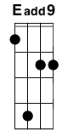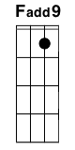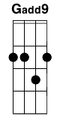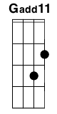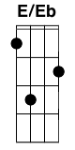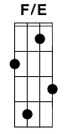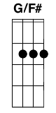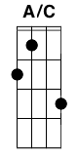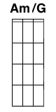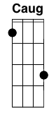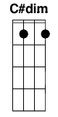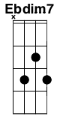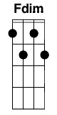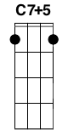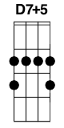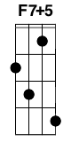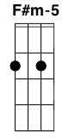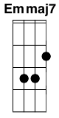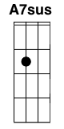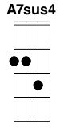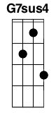

Variations

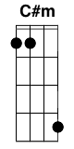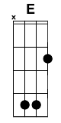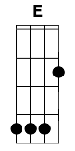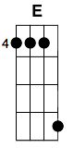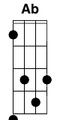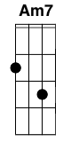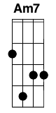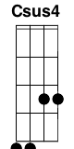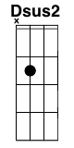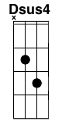

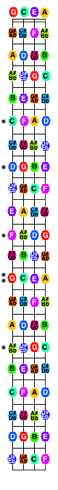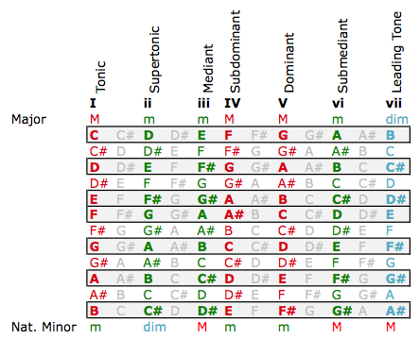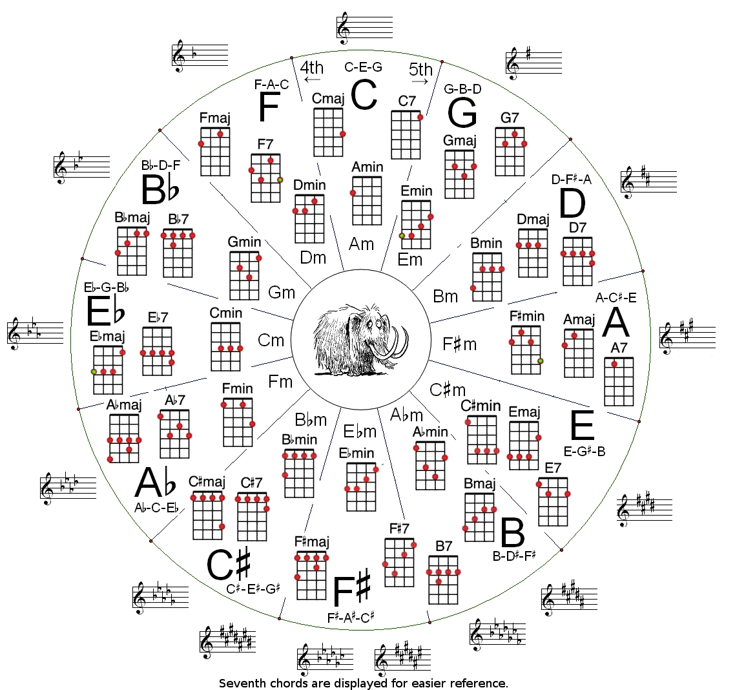

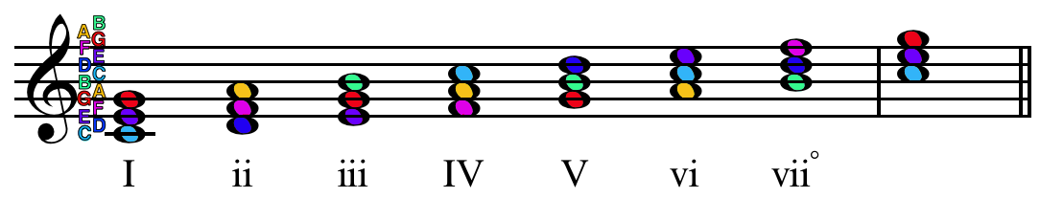

*Cover Image - (c) 2011 - Rachel http://www.nearsightedowl.com*